**AWS Cost Optimization using Lambda**

**Introduction**

Managing cloud cost effectively in AWS. One way to optimize costs is by identifying and removing unused resources.

EBS snapshots are backup of EBS volumes. When the instance and ebs volumes is deleted but snapshots was not deleted. These unused snapshots take up more space and increase the unnecessary costs.

We’ll create a lambda function that automatically finds and delete the unused snapshots. Helps you to manage costs effectively.

First we’ll create the EC2 instance.

Loged into AWS.

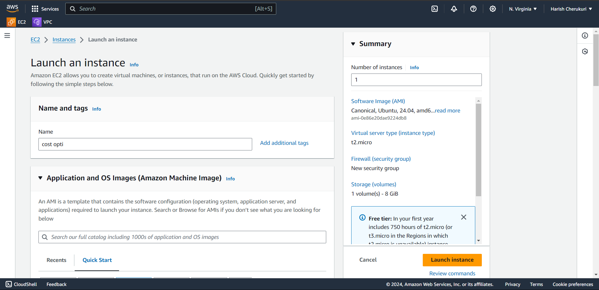

Give the instance and select the AMI as ubuntu.

Select the instance type is t2 micro.

Select the key pair.

Select the security group and ensure that ssh port 22 is allowed.

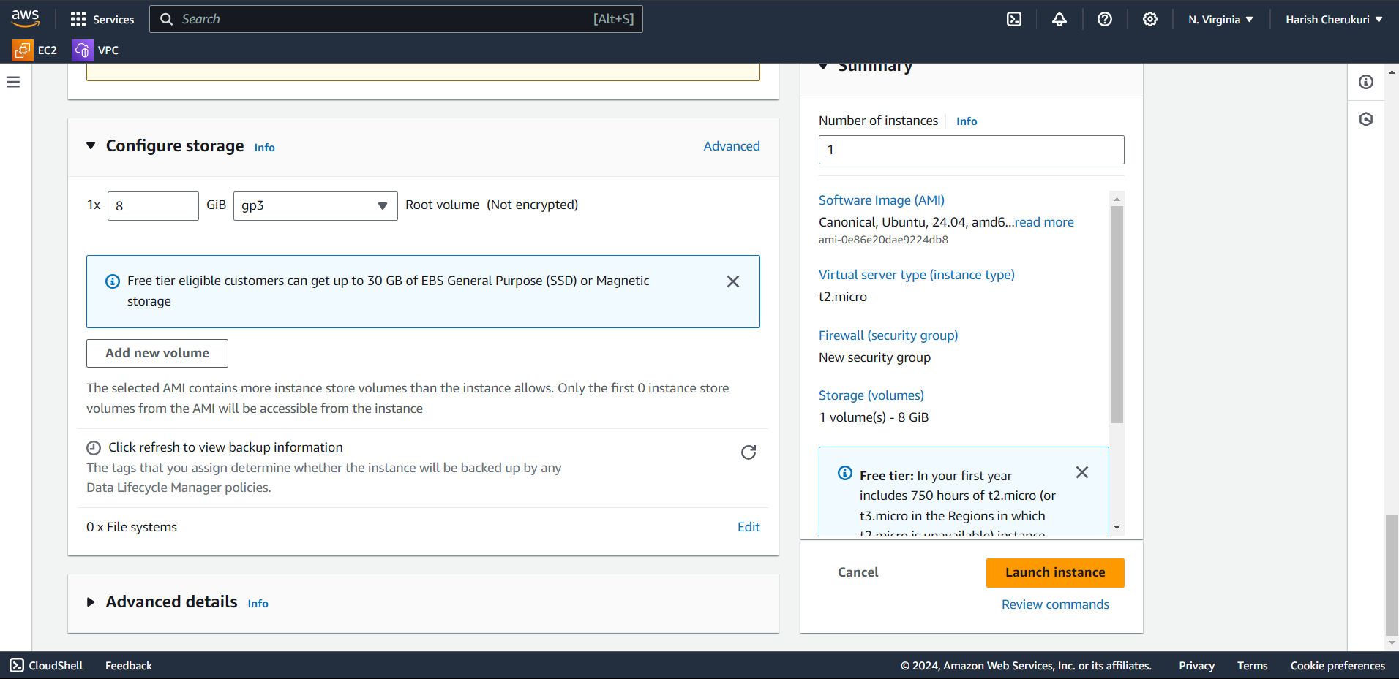

Keep the storage volume as default.

Click on launch instance.

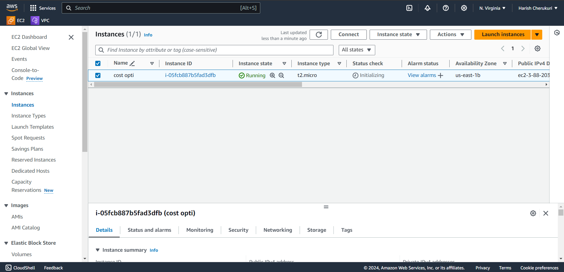

Instance is created now go to storage you can see volume is created automatically by launching instance.

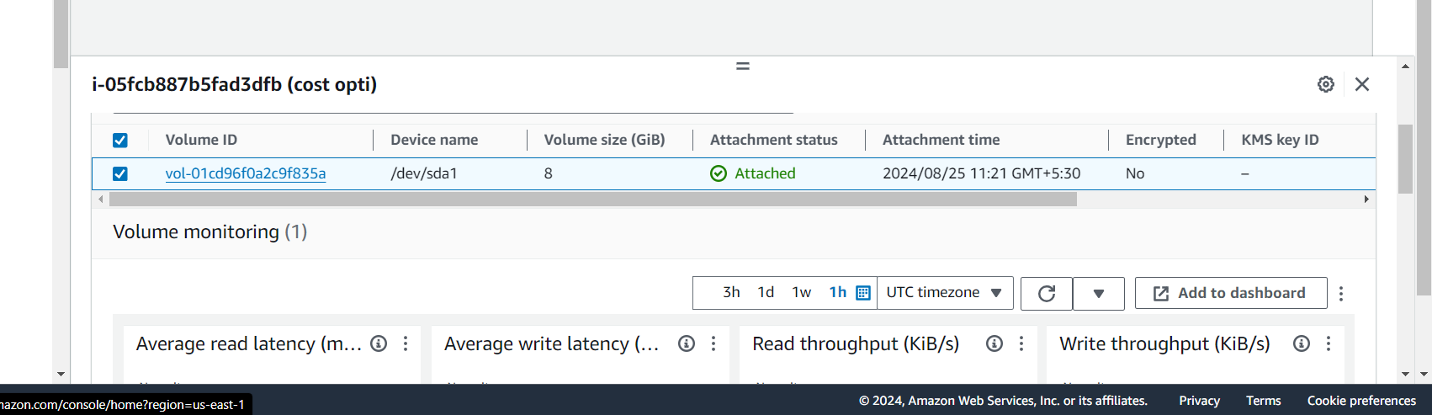

Volume is created.

Now create the snapshot for volume.

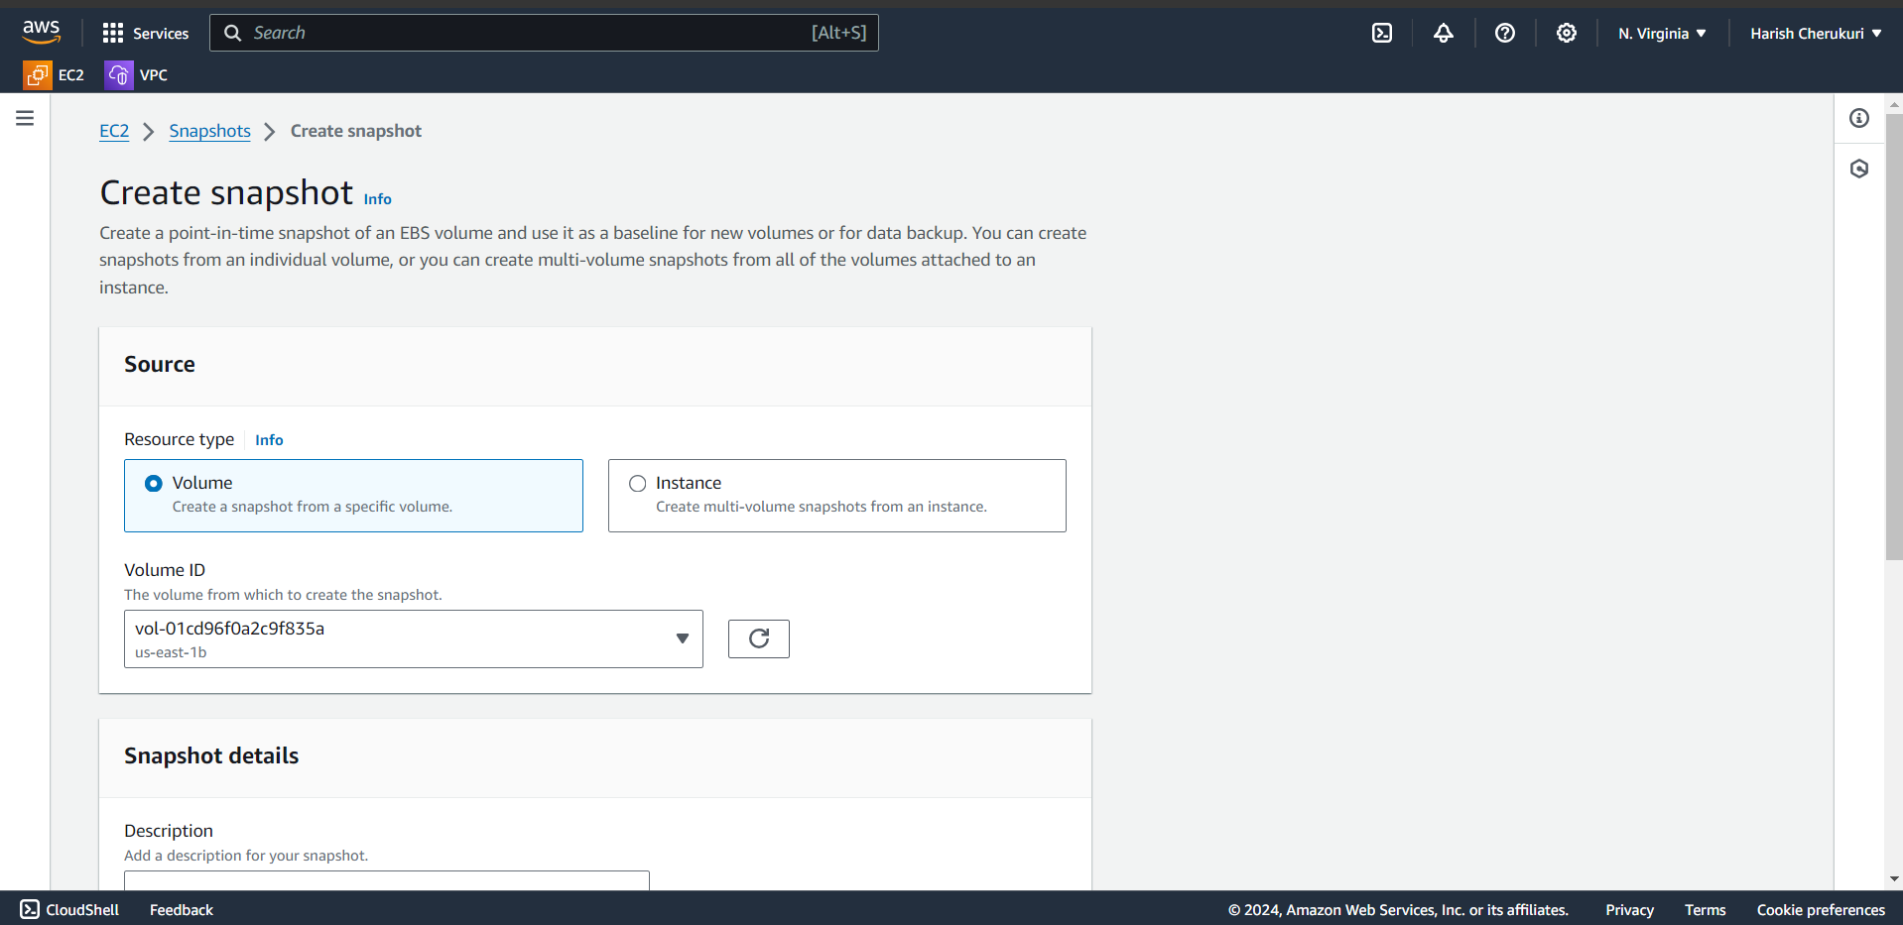

Select the volume we are creating snapshot for volume.

Select the created volume.

Click on create snapshot.

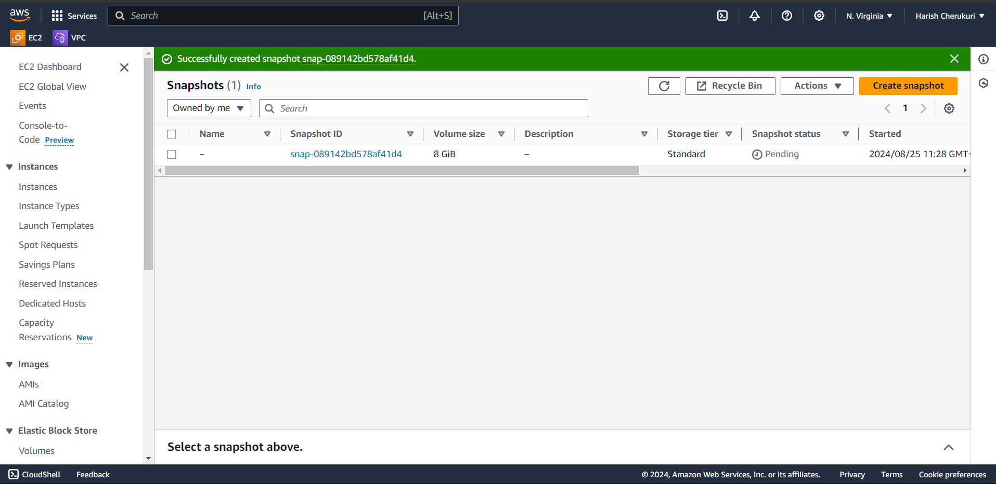

Snapshot is created.

Now create the AWS Lambda.

Creating aws lambda function that allows to run the code with provisioning or managing server.

AWS lambda can identify and delete the unused snapshots.

Now create the lambda function.

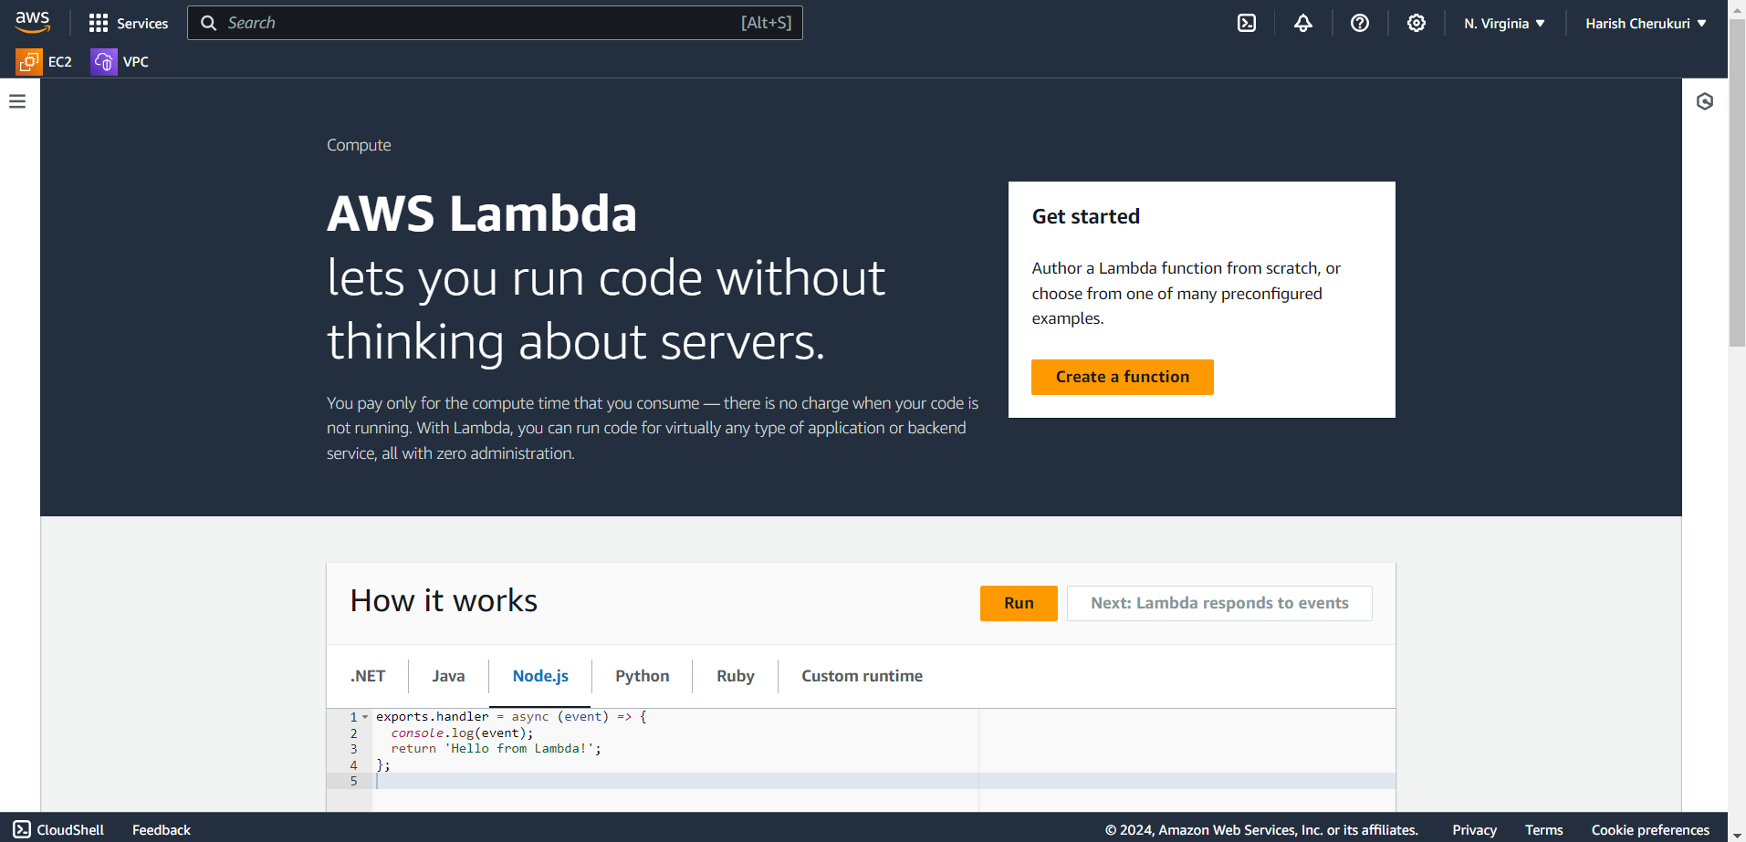

Click on create function.

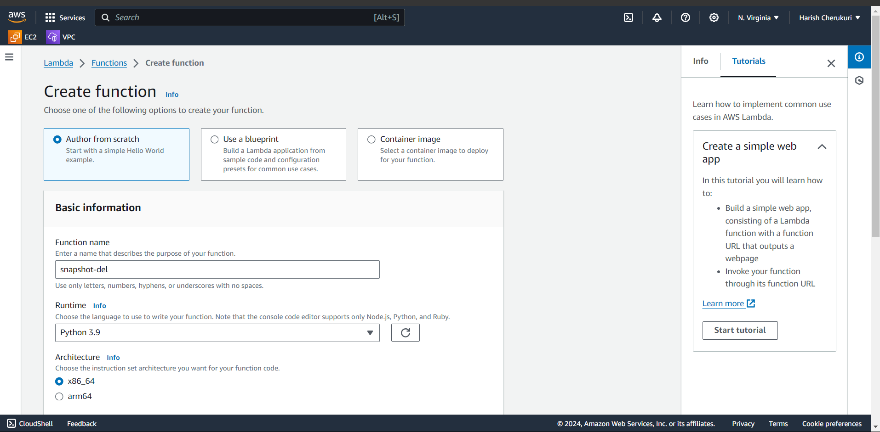

Select the author from scratch.

Give the function name.

Select the runtime on which language to write your function.

I am go to run it on python.

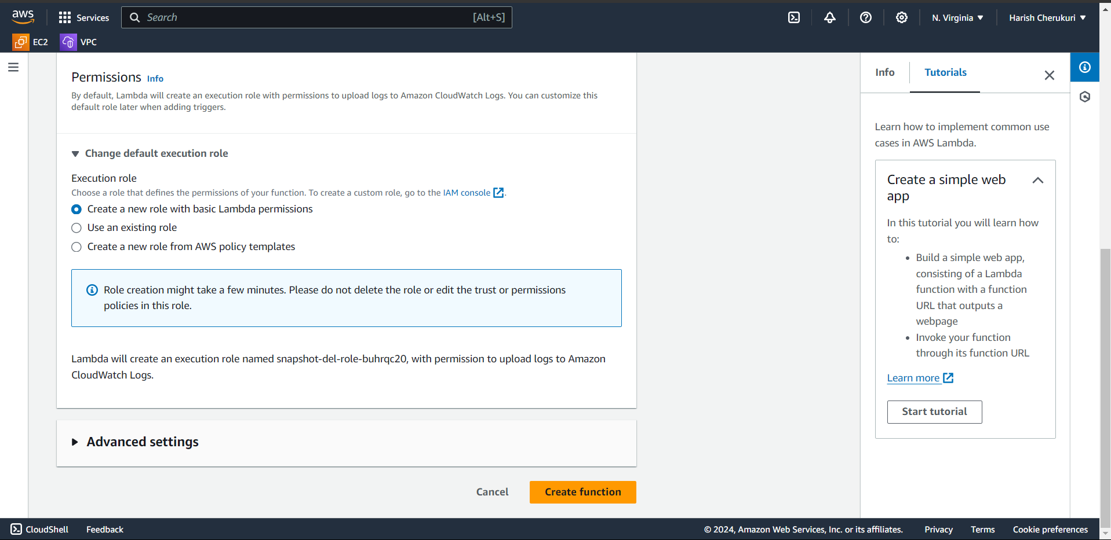

Select the create new role.

Click on create function.

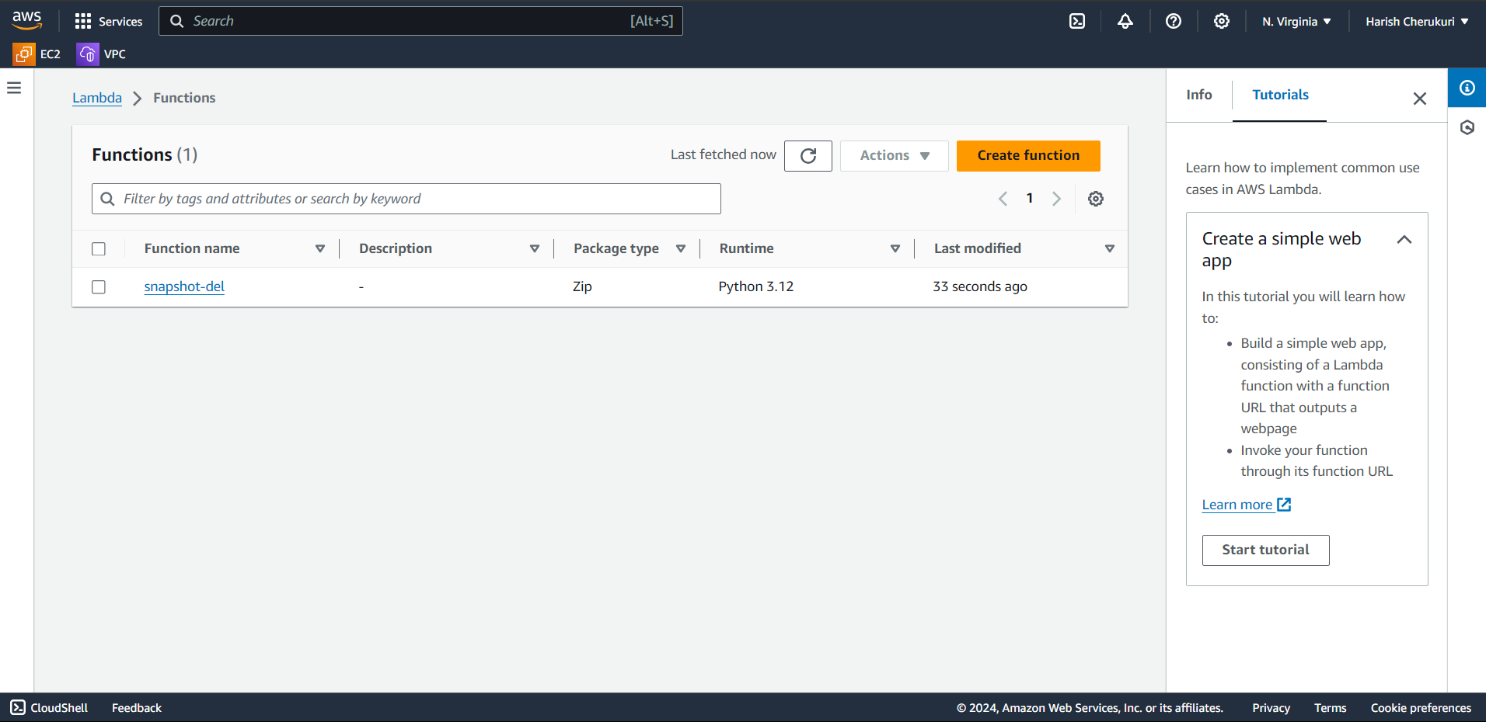

Lambda function is created.

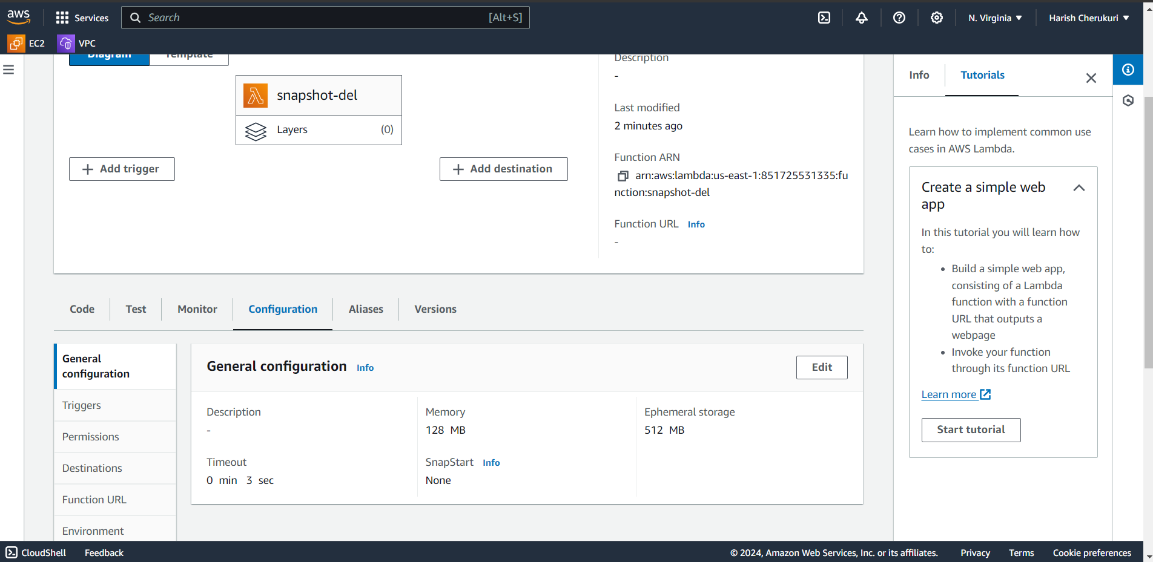

Go to configuration.

Click on edit and change timeout by default it is 3 sec we are changing it to 10 sec.

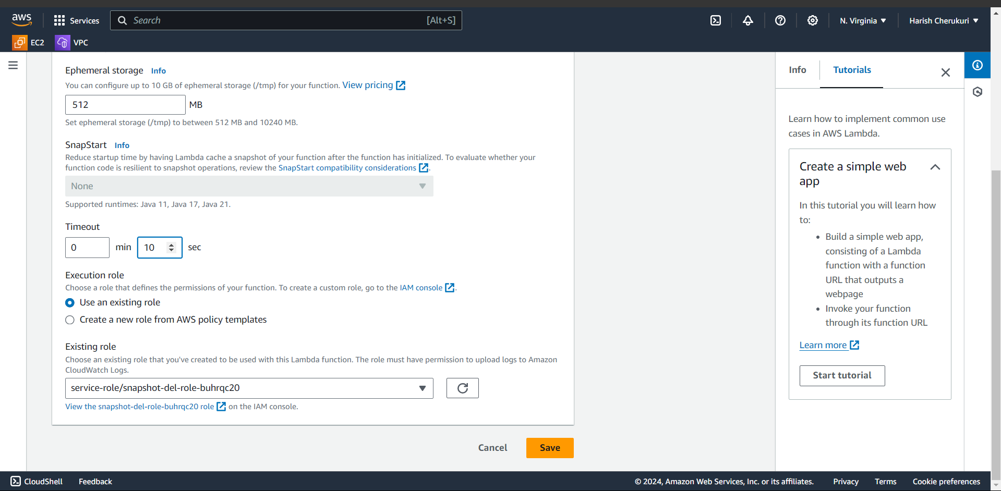

Click on save.

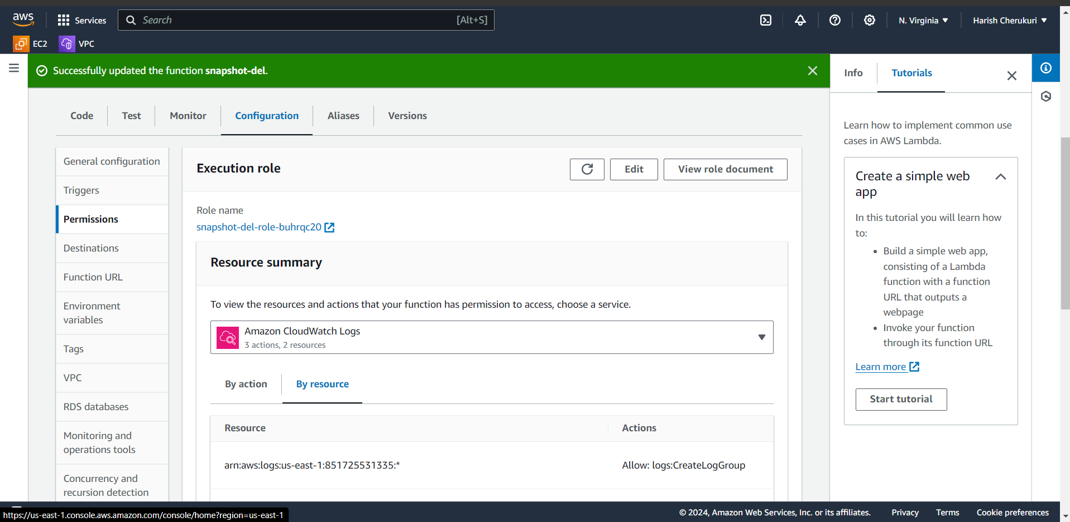go to permissions iam role is created.

Go to role.

In this cost optimization, the lambda function is to optimizing the cost of AWS by identifying and deleting the unused snapshot.

So, to do that lambda function need some specific permissions. These include describe snapshot and delete snapshot as well as describe volume and instance.

Roles are used to access to aws resoures.

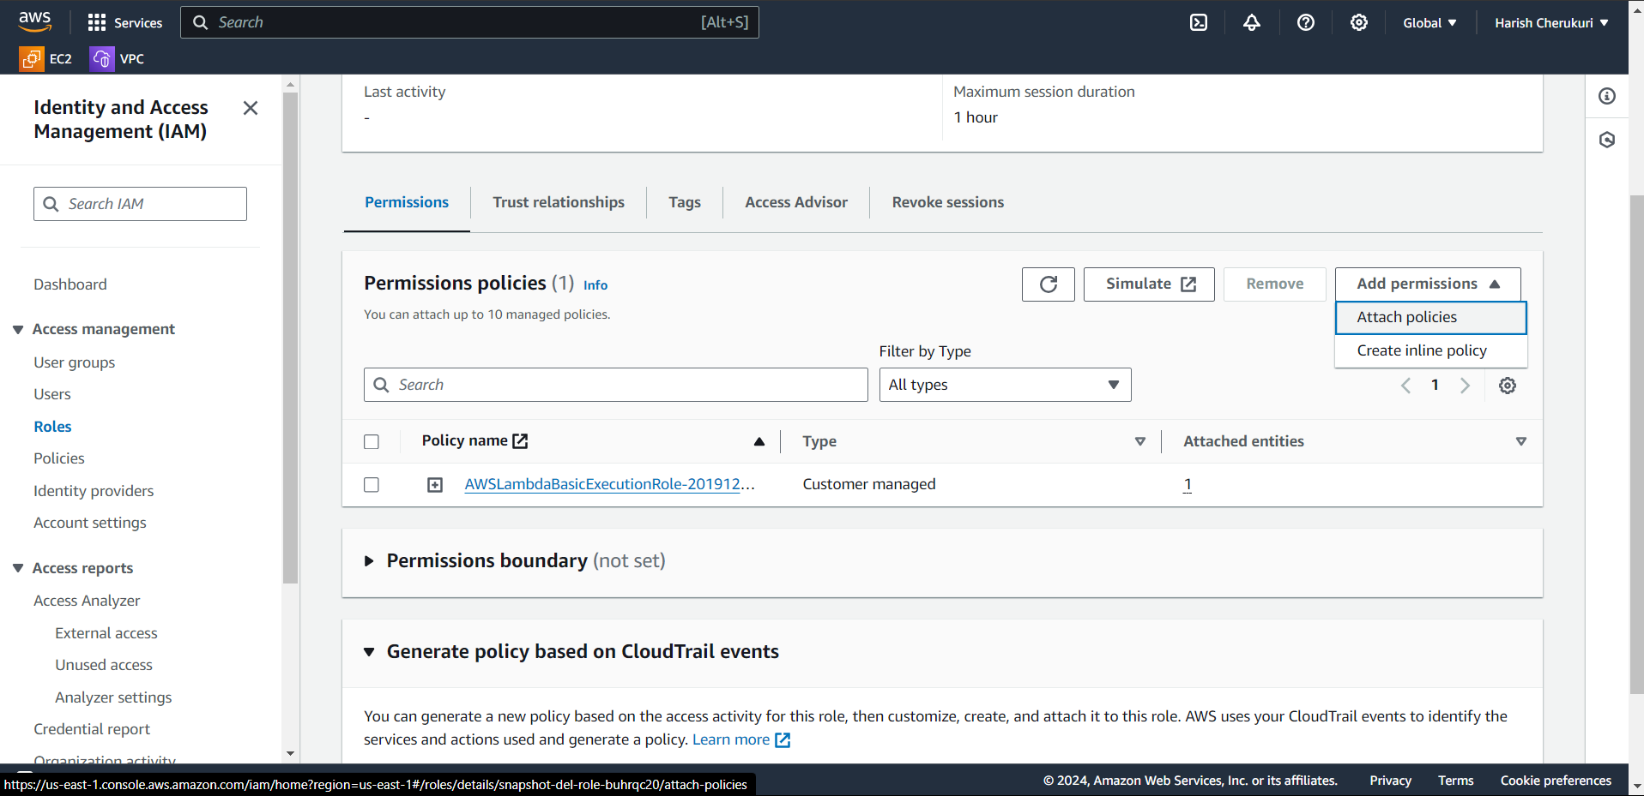

Click on create inline policy.

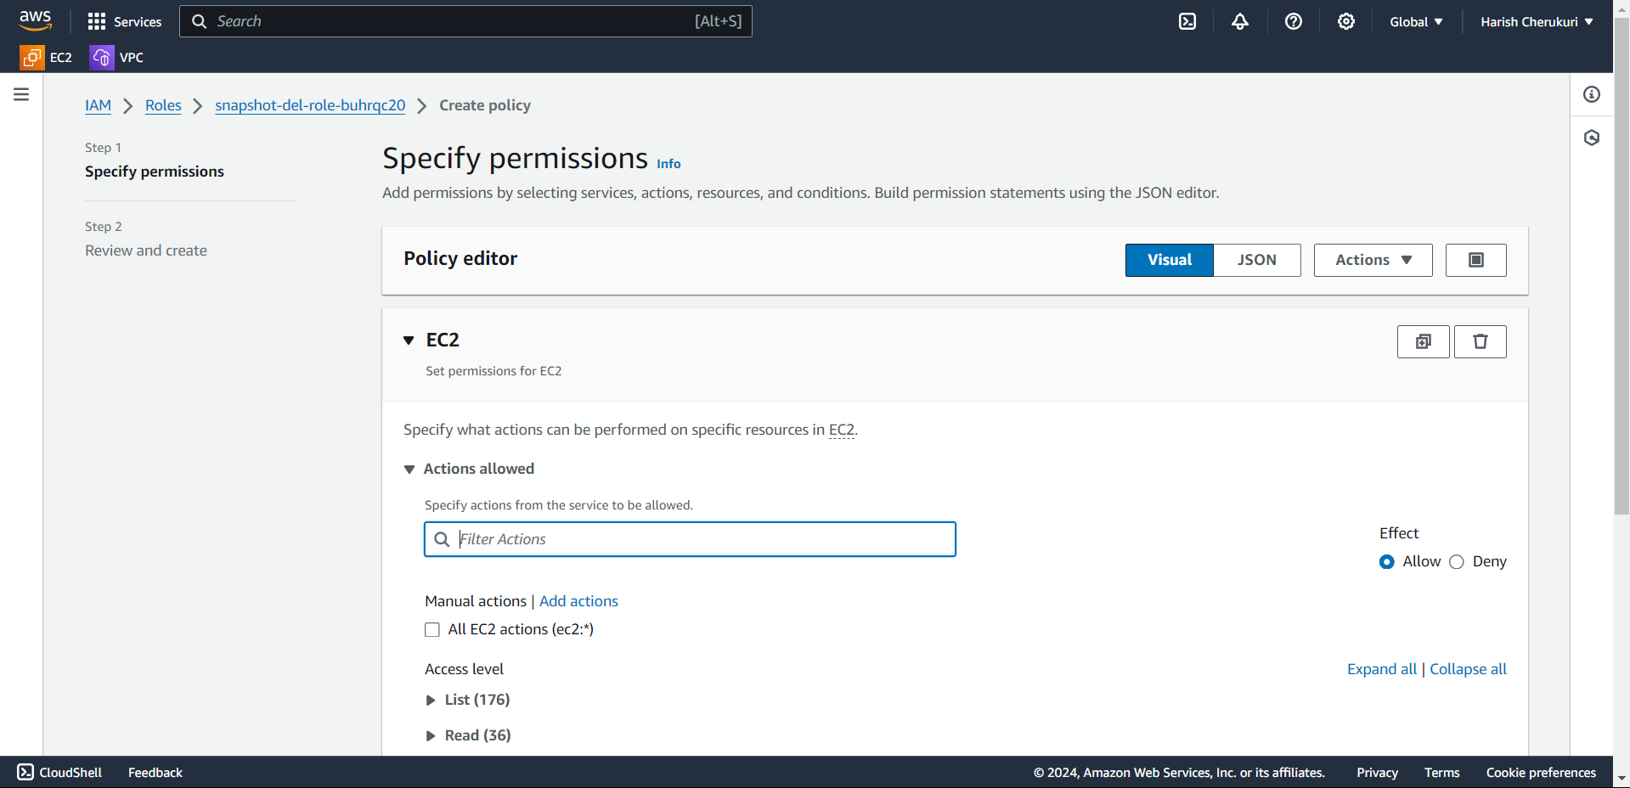

Select the for which service you to want to create the role.

We are going to create for ec2. So select the ec2.

Add permissions on snapshot.

Describe snapshot.

Delete snapshot.

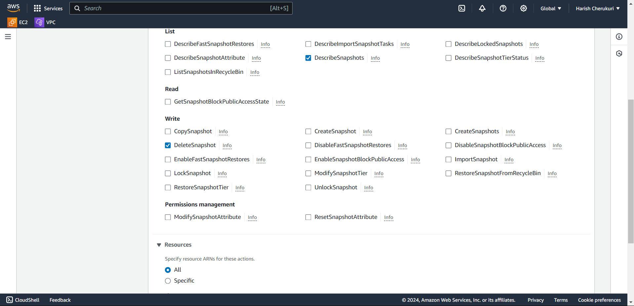

Select the arm as all.

Click on next.

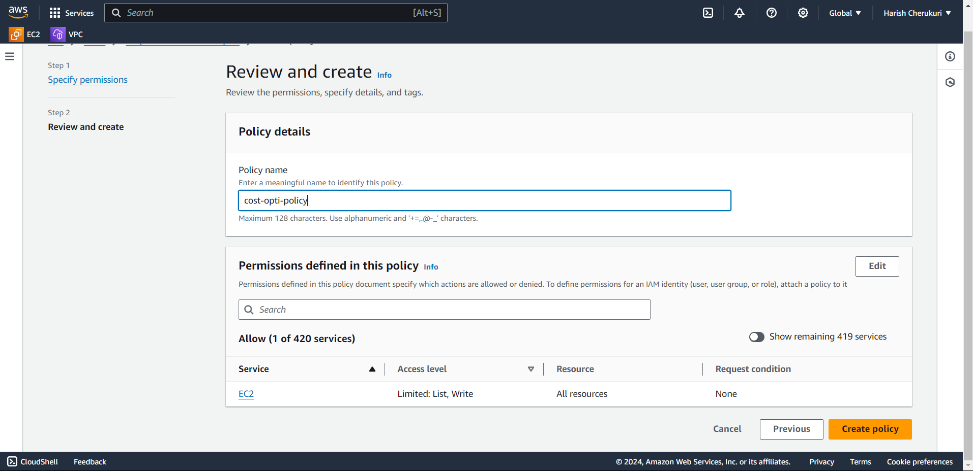

Give the policy name.

Click on create policy.

Go to lambda function. Paste the python.

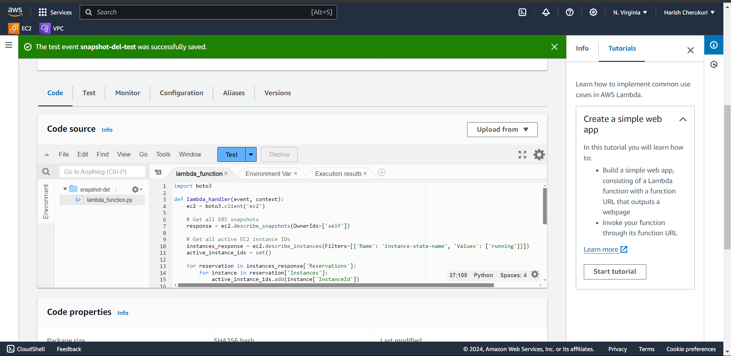

First we need to deploy it next test the code.

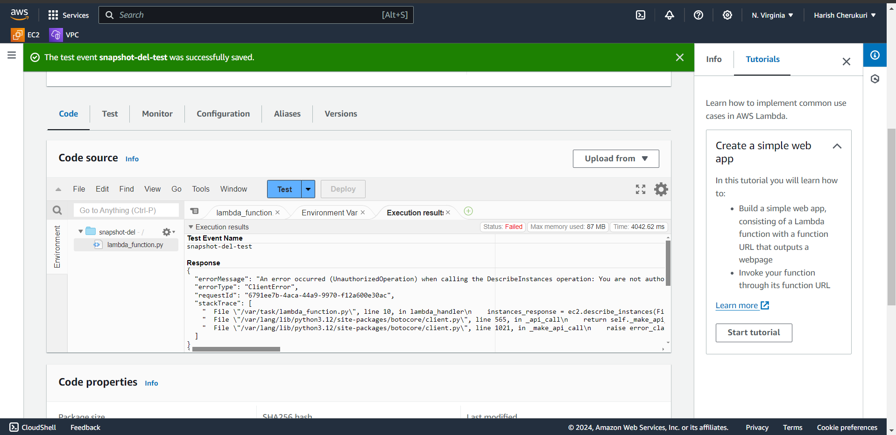

We got an error.

Because we does not give any permissions to ec2.

So, go to roles and add ec2 permissions.

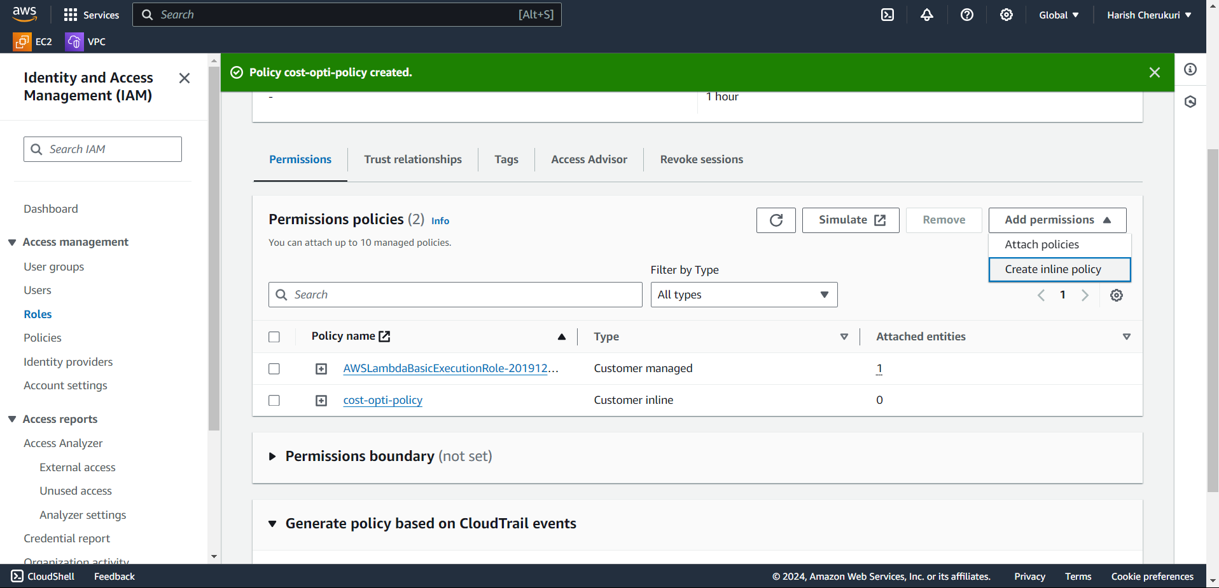

Click on create policy.

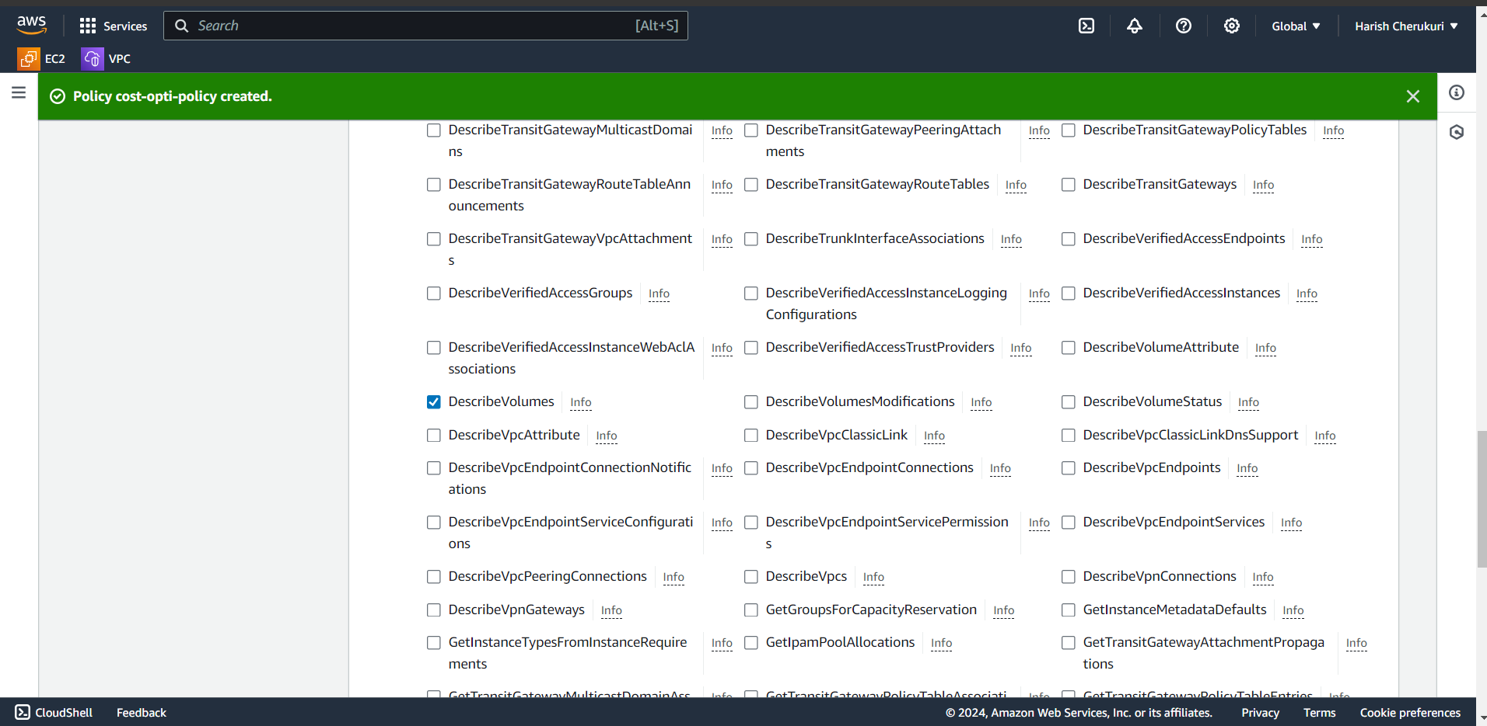

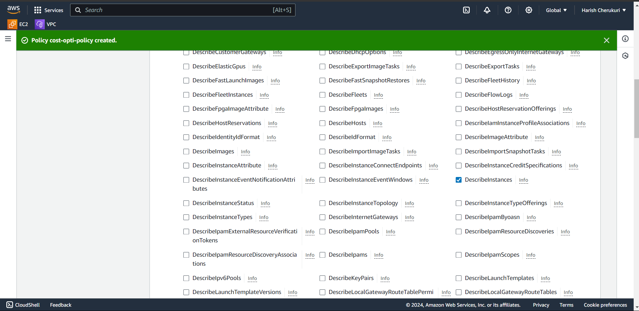

Select the describe volume and instance.

Click on next.

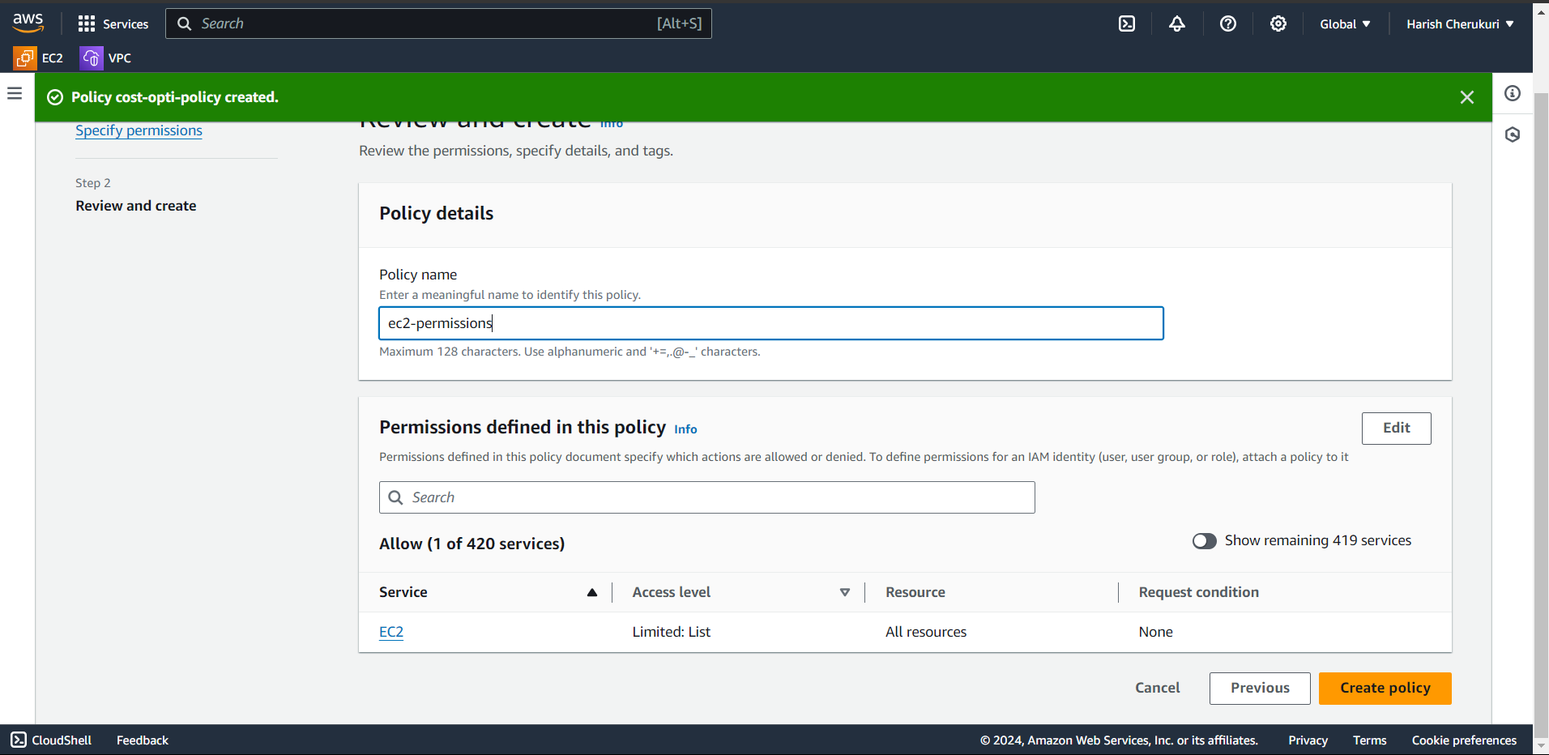

Give policy name.

Click on create policy.

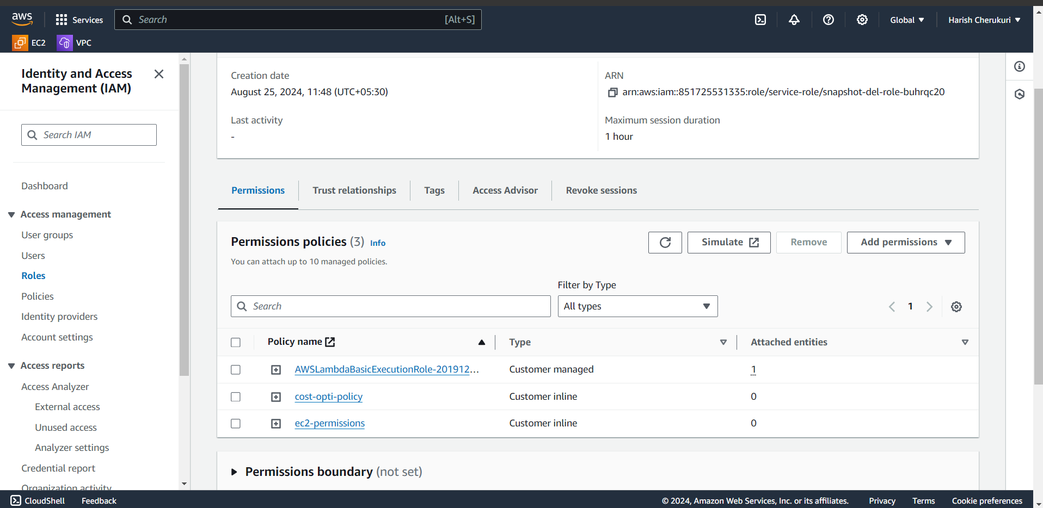policy is added to role.

Now go code test the code.

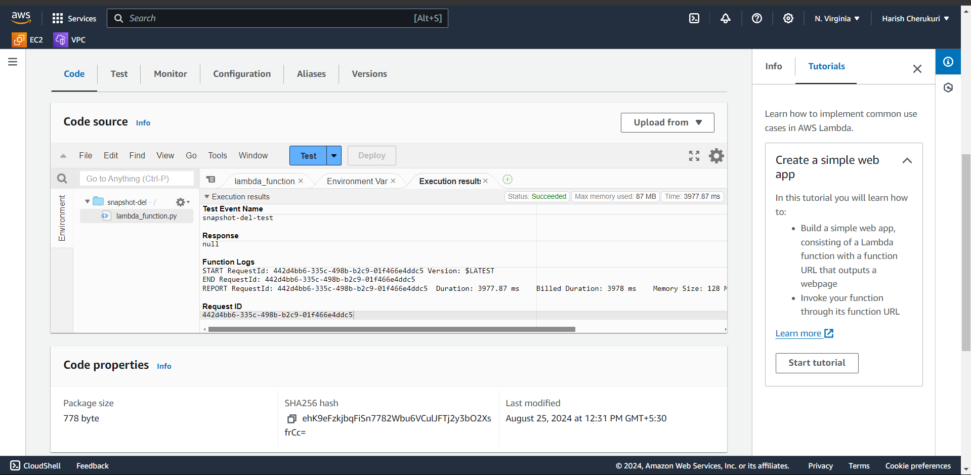

We got success.

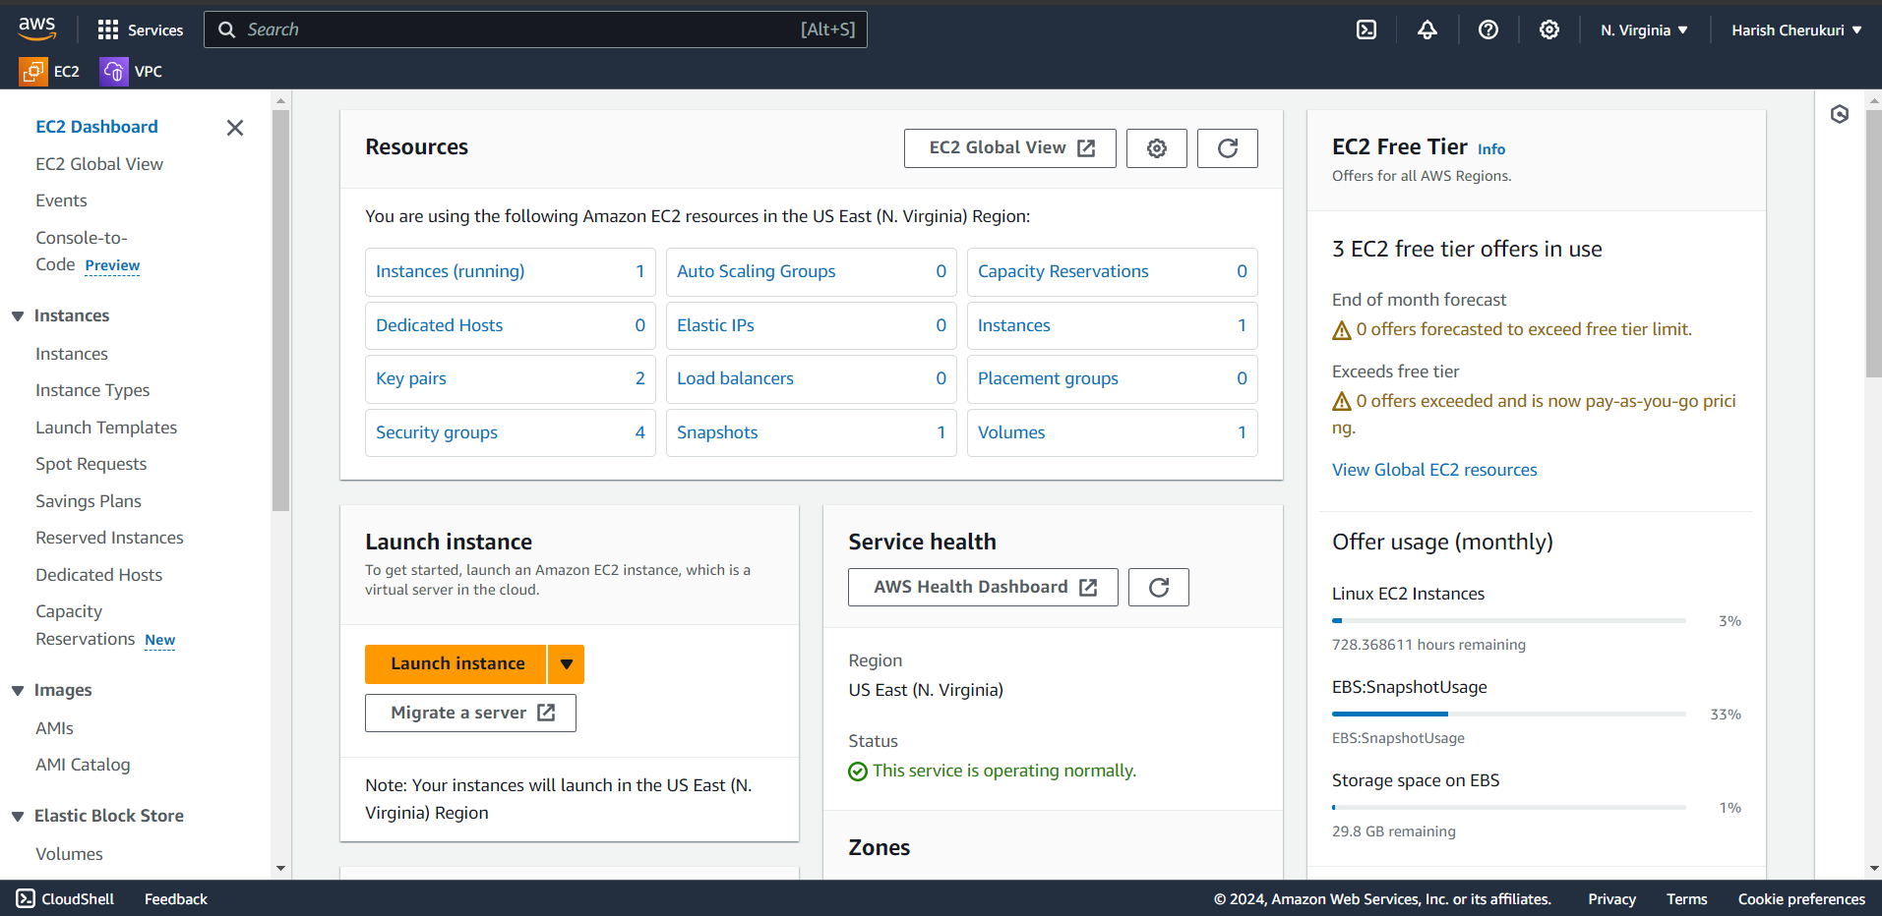

The snapshot was not deleted. Because the instance is running.

Now we delete the instance if delete the instance the volume also automatically deleted.

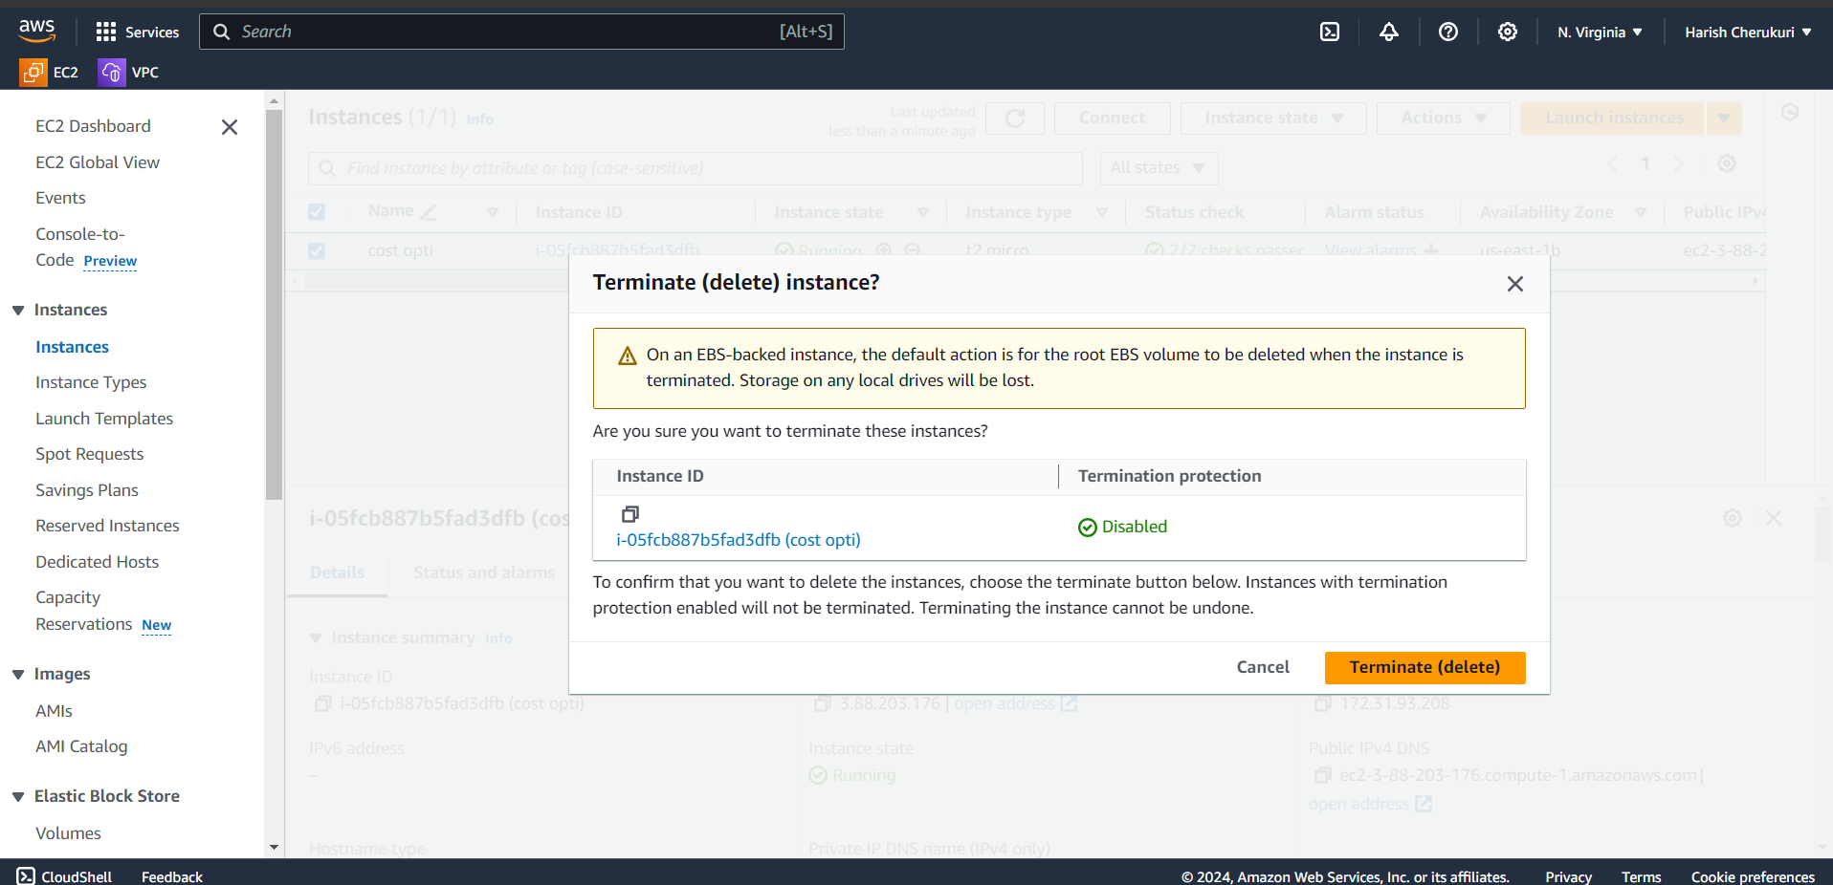

Terminate the instance.

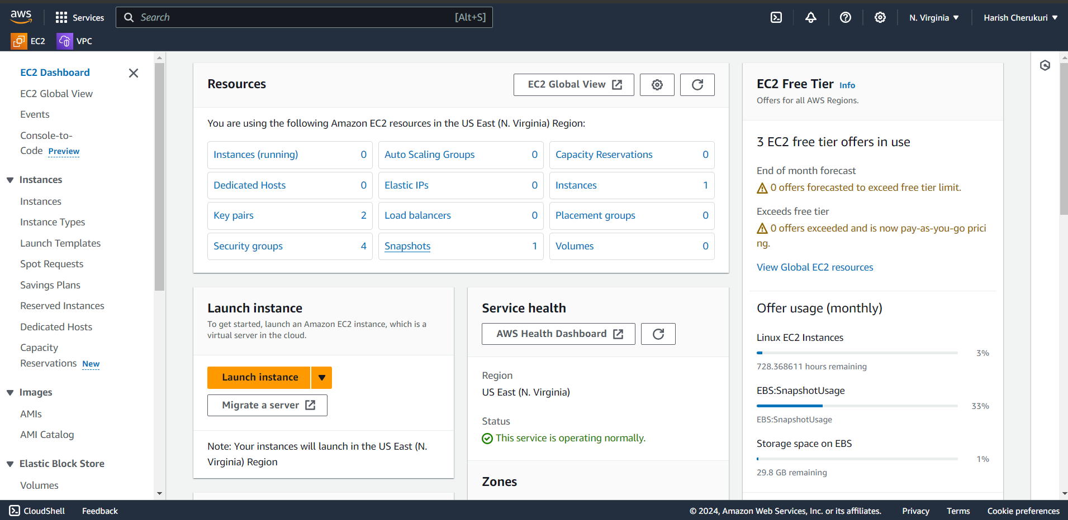

The instance and volume is deleted but snapshot was not deleted.

Now go to lambda function test the code again.

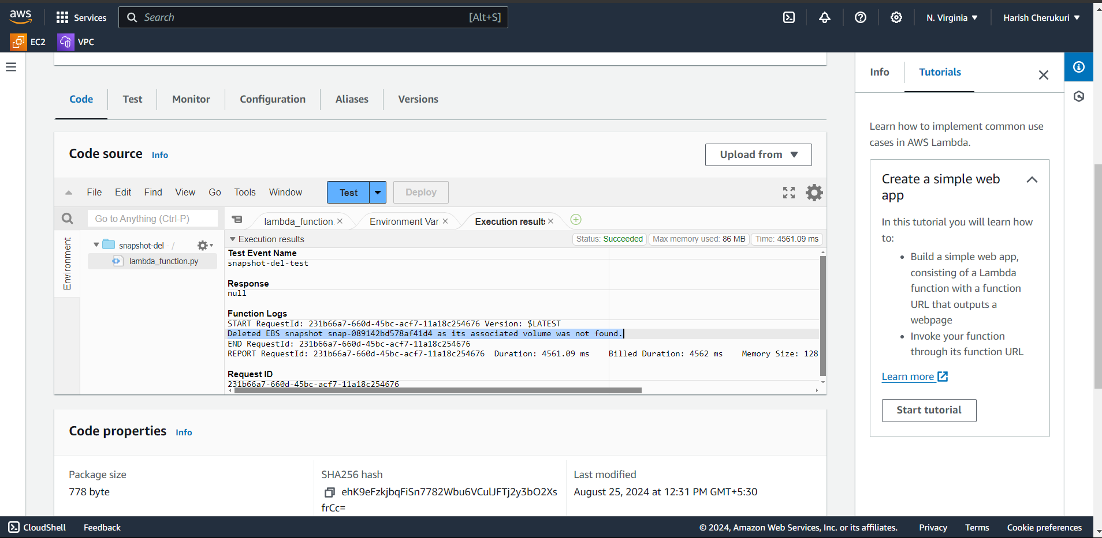

See in the result.

Deleted the snapshot because its associated volume was not found.

Check if snapshot was deleted are not.

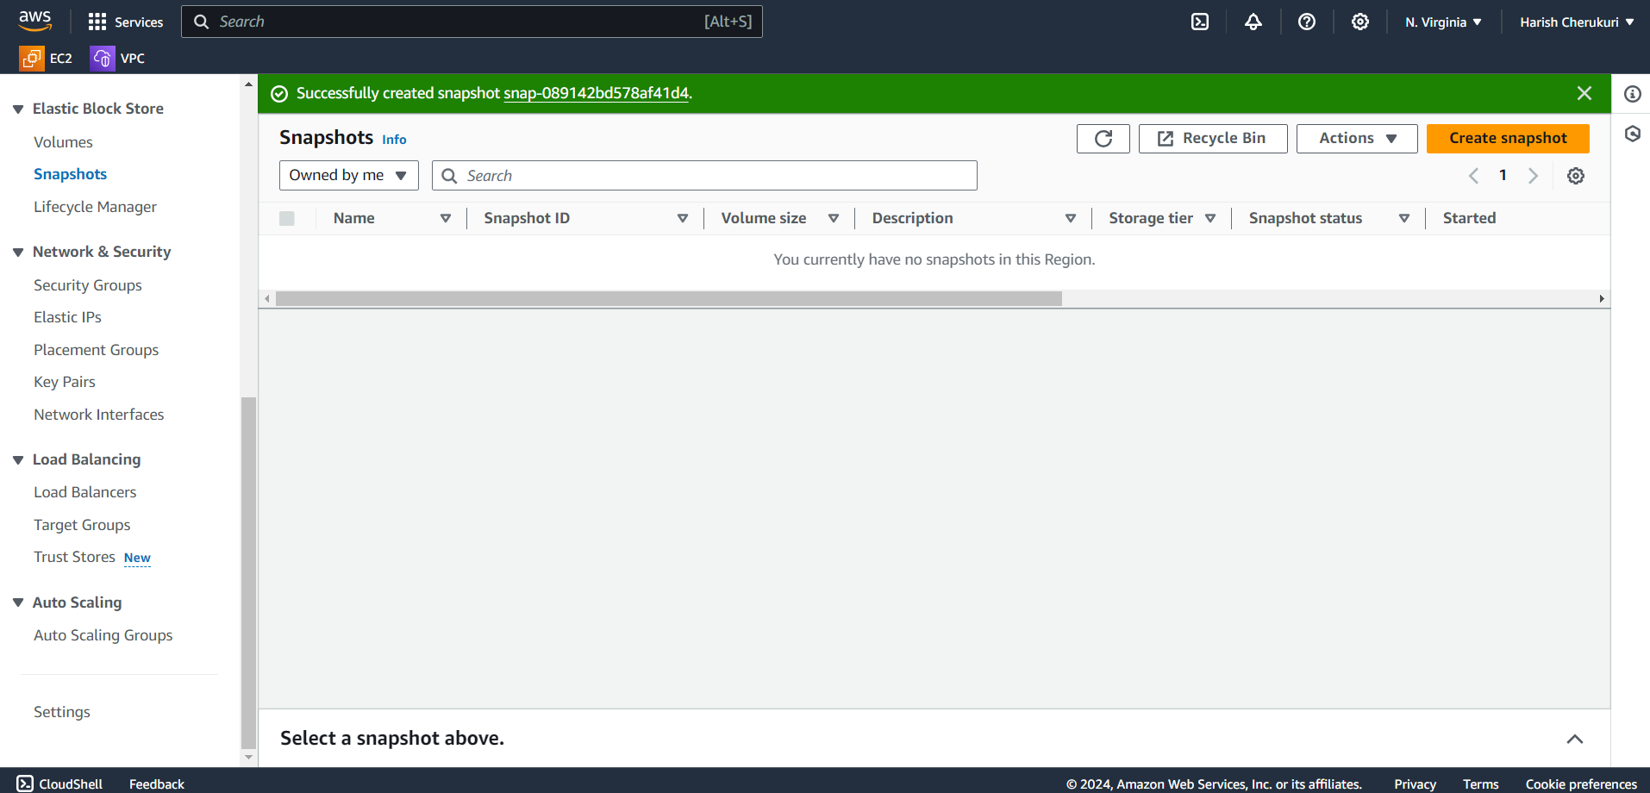

Snapshot was deleted.

**Conculsion**

So, we conclude that by using lambda function we can manage costs in AWS.